Beef and Sheep Medicine Course

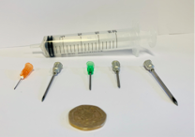

Responsible, Safe and Effective Use of Medicine on Farm

(as part of the farm assurance requirements)

10.30am - 2pm on the 29th June 2021
With Lunch

At

Dupath Farm, Callington. PL17 8AD

With Thanks to the Coombe Family
(follow course signposts off the Callington to St Annes Chapel Road)

Cost :£45

(As many of the team members are encouraged to attend with an attendance fee of £15 each for the 2nd or more attendee from a farm.

Course facilitated by

Michael ‘Spike’ Head

